Project Report

# GitHub URL

https://github.com/rupaligs/UCDPA_Rupali_Murkumbi

# Abstract

This project is about the analysis of travel trends and impact due to weather. This project will look at if there is any variation in travel because of change in weather (rainfall, temperature, and sunshine) in Ireland.

# Introduction

* Personal motivation:

I have experienced that the weather in Ireland is very unpredictable and I wanted to see if people decide to travel based on the weather.

* Why is the business problem important:

This analysis can be useful for the tourism industry to prepare for tourists based on weather conditions.

* Can it be converted to data analytics problem:

If trends show that there is an impact on travel due to weather conditions, this can convert into data analytics problem to predict and prepare.

# Dataset

* This dataset is available on website of central statistics office data.cso.ie. The travel data has been collected by CSO office as part of the surveys and weather data is provided by Met Eireann to CSO.

|  |  |  |
| --- | --- | --- |
| Dataset ID | Dataset Name | Source |
| HTQ01 | Travel by Irish residents | <https://data.cso.ie/table/HTQ01> |
| MTM01 | Rainfall | <https://data.cso.ie/table/MTM01> |
| MTM02 | Temperature | <https://data.cso.ie/table/MTM02> |
| MTM03 | Sunshine | <https://data.cso.ie/table/MTM03> |

* Description of the variable(columns) in the dataset

**HTQ01**

|  |  |  |
| --- | --- | --- |
| Field | Description | Contents example |
| Statistic |  |  |
| Quarter | Quarter of the year | 2022Q1  2021Q2 |
| Domestic | Type of journey | Domestic  Outbound |
| Reason for journey |  |  |

**MTM01 (Rainfall)**

|  |  |  |
| --- | --- | --- |
| Field | Description | Contents example |
| Statistics |  |  |
| Month |  |  |
| Weather station |  |  |

**MTM02 (Temperature)**

|  |  |  |
| --- | --- | --- |
| Field | Description | Contents example |
| Statistics |  |  |
| Month |  |  |
| Weather station |  |  |
|  |  |  |

**MTM03 (Sunshine)**

|  |  |  |
| --- | --- | --- |
| Field | Description | Contents example |
| Statistics |  |  |
| Month |  |  |
| Weather station |  |  |
|  |  |  |

# Implementation Process

* Data Importing
  + All the csv files were downloaded and imported into panda frames
  + Checked for number of rows for each file.

e.g.

rainfall=pd.read_csv('dataset/MTM01.20230430T170443.csv')

* + Created database travel_ireland in SQLite
  + Imported csv file of travel details into table travel_ireland
* Data Cleaning
  + Checked for data types of imported csv files
  + Checked for null or missing values.
  + Fixed the missing values using *dropna* function
  + Merged the data frames rainfall, sunshine, and temperature on month of the year
  + Separated year and month from column Month
  + Created extra column Quarter using the values from Month column to join with travel data
  + Created new dataframe to group by on values of rain, sunshine and temperature on year and quarter.
  + Created year column on travel data frame
  + Merged travel and weather datasets

Figure 1

* Data Exploration
  + Exported each data frame in csv file to analyze the results after each operation (e.g., Fixing missing values, merging)
  + Applied various filters to explore and analyze data
  + Created function in order to produce graphs/charts by passing year parameter
  + Executed SQL queries in SQLite database to analyze travel data

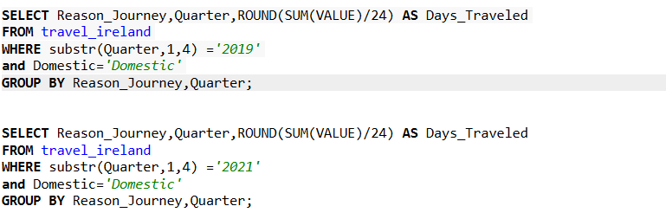

Figure 2

* Data Visualization
  + Generated various charts (e.g., Weather trends for month, quarterly weather trends with travel)
* Data Modelling
  + Regression model will suit this data analytics problem

# Results

Figure 3 - Bar chart for 2019

Figure 4 - Bar chart for 2020

Figure 5 - Bar chart for 2021

Figure 6 - Bar chart for 2022

Add snapshots(picture) of your code where relevant

Results of data exploratory

Results of data visualization

Results of modelling (visualization)



Figure 7

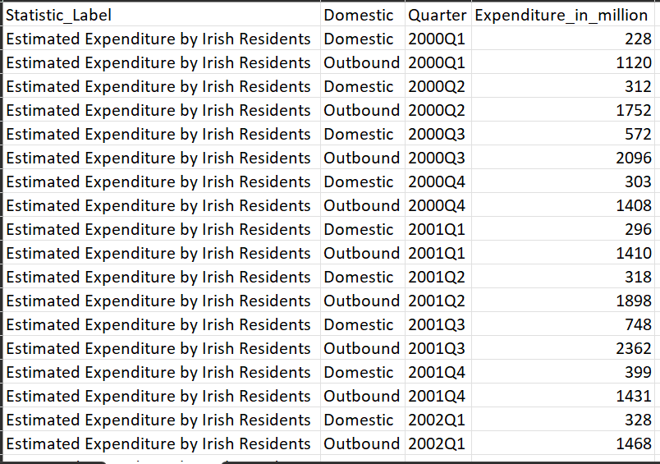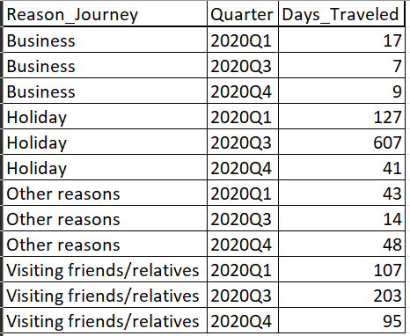

Figure 8 Figure 9 - 2020

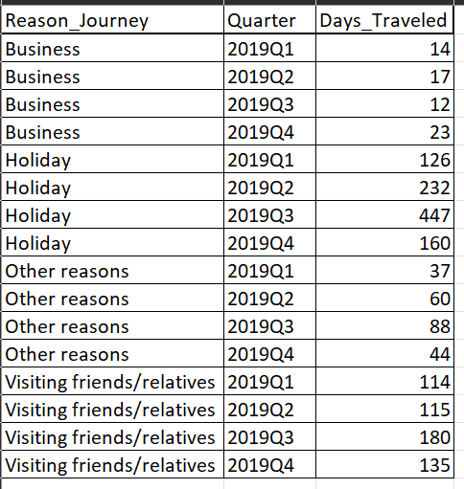 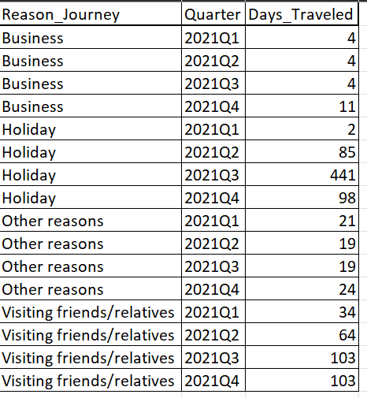

Figure 10 - 2019 Figure 11 -2021

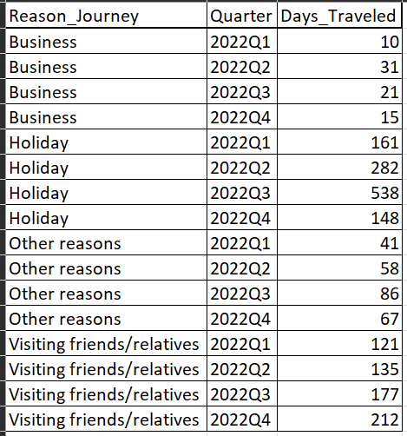Figure 12 - 2022

# Insights

1. In the year 2020Q2, there is no travel, neither domestic nor outbound due to travel restrictions.

As the 2020Q3 include the summer and school holidays, families had more time to spend together as students have more free time. Since 2020 was the year when travel abroad restrictions were still in place, people were encouraged to partake in ‘staycations’ which caused people to still travel around the country.

In the year 2020Q1, 2020Q3, 2020Q4 in 2020Q3 most of the travel is for holidays and to visit friends and relatives.

1. The graph in figure 4 shows that very few people travelled in 2020 in the second quarter. Although the rainfall for this quarter is less than the other three years and the temperature is roughly the same as other years, less people travelled in 2020 within the second quarter than the other three years. In this case, the COVID 19 restrictions can be the most likely reason as people were advised to decrease their travelling to avoid the spread of COVID 19.
2. In figure 4, 2020Q4 shows that a lot less people travelled in comparison to other years. However, COVID restrictions were relaxed during this quarter to allow people to celebrate Christmas despite the rising COVID 19 cases which explains why some people still travelled during this time. In the following year, 2021Q1 displays that very few people travelled during this time compared to any other year even though temperature and rainfall are similar to other years. This is because COVID 19 restrictions were placed again after an increase in cases.
3. In general, many people prefer to travel within the 3rd quarter as there is a rise in temperature and sunshine.
4. The trends for people travelling in the graphs shown in figure 3 and figure 6 are similar. The number of people that travel increases steadily from the 1st quarter to the 3rd quarter, and then it falls noticeably in both of these graphs. This is because in 2019 COVID 19 restrictions had not come into place yet, and therefore, people were free to travel any time during the year. In 2022 COVID 19 restrictions in Ireland were fully lifted which allowed people to freely travel once again.

# References

Dataset references: data.cso.ie

|  |  |  |
| --- | --- | --- |
| Dataset ID | Dataset Name | Source |
| HTQ01 | Travel by Irish residents | <https://data.cso.ie/table/HTQ01> |
| MTM01 | Rainfall | <https://data.cso.ie/table/MTM01> |
| MTM02 | Temperature | <https://data.cso.ie/table/MTM02> |
| MTM03 | Sunshine | <https://data.cso.ie/table/MTM03> |